Date and Time: 02/18/16 - 10pm to 11pm (1hr 30 min)

Participants: Ammar, Tom, Michael and Tan

Location: Google Hangout and Group Text

Topics discussed:

1. Ammar bought new webcam that could work on Matlab (logitech c270 instead of ps3 eye)
2. Tom said yes!!! Tom talked to Vadhva about laser drive. He suggested we should buy one but still try to make one.
3. Michael said he has bought a lot of components
4. So far, Tan and Ammar agreed on using Matlab for computer vision.
   1. Ammar will try to apply the algorithms from machine visions to test the camera functions on matlab by hand-coding and using built-in function
   2. Tan will build a bridge using server concept to communicate between matlab and python, so that the info will be transmitted to microcontroller for later used.
   3. “takes a picture using the camera, then the image taken will be used to find the dimensions of the object, and then the dimension will be written or extracted as file in a matrix format or array (i'll have to look more into that) so that python can take these data and update the microcontroller,” quoted Ammar.

Documentation:

Useful links:

<https://www.cl.cam.ac.uk/projects/raspberrypi/tutorials/image-processing/intro.html>

That shows how to apply edge detection on raspberry pi

<https://arokem.github.io/python-matlab-bridge/>

<http://stackoverflow.com/questions/18435546/communication-between-python-and-matlab>

Shows how to communicate between python and matlab

Date and Time: 02/19-20/16 - Afternoon (15 min)

Participants: Ammar, Tom, Michael and Tan

Location: Group Text

Topics discussed:

1. Tom had steppers drivers
2. Tom also had the design for the panel
3. Michael gonna start buying 445nM safety glass

Documentation:

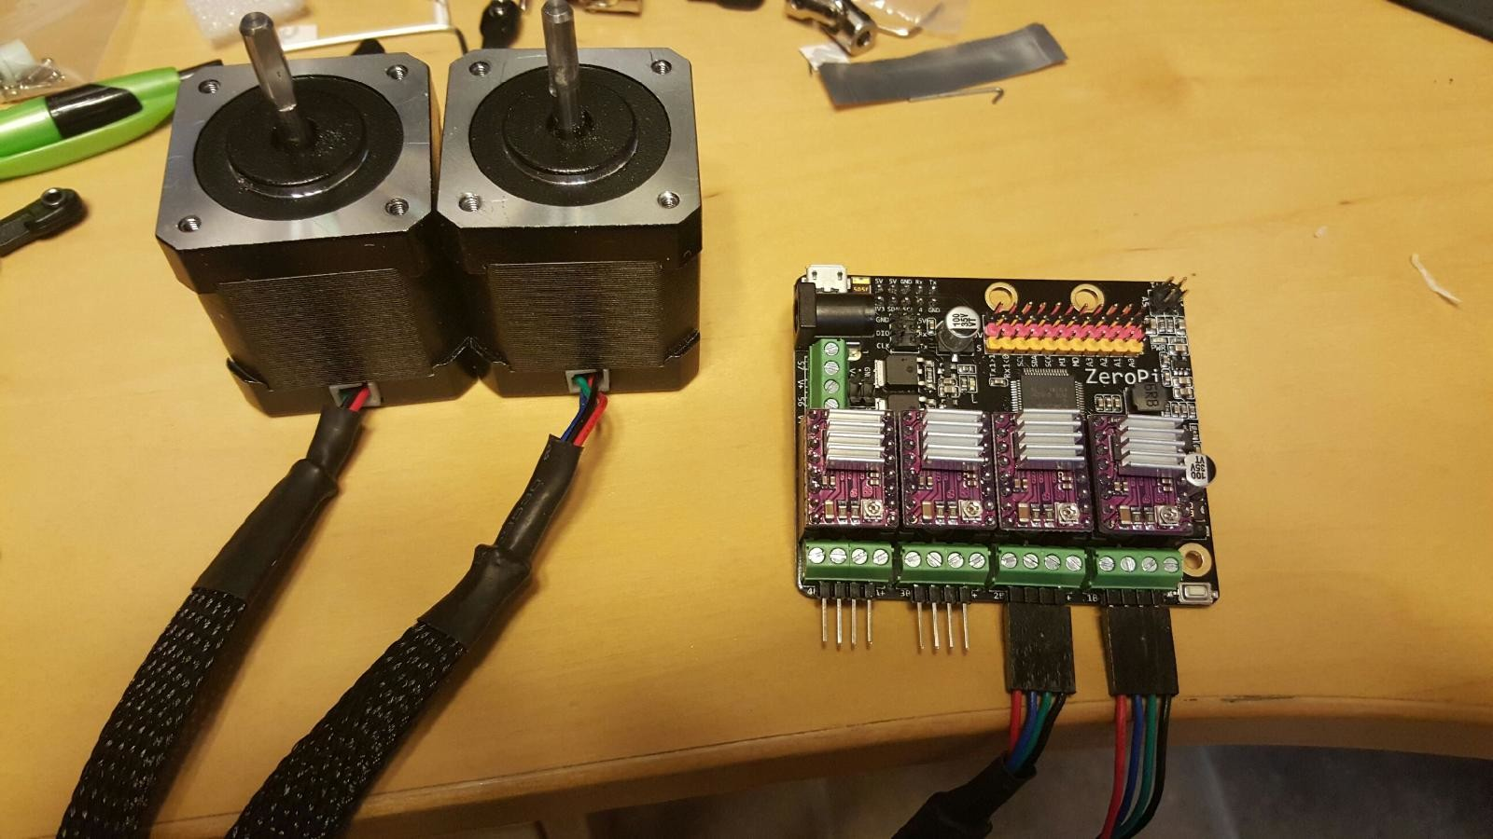

Parts Purchased for Laser:

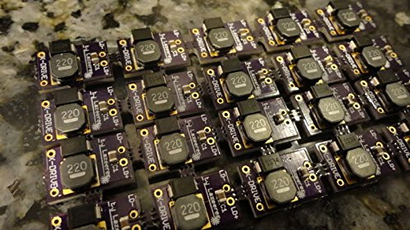

# **1.8A X-Drive V6 Laser Driver - M140 - PLTB450 - PLTB450B - NDG700 - NDG7475**

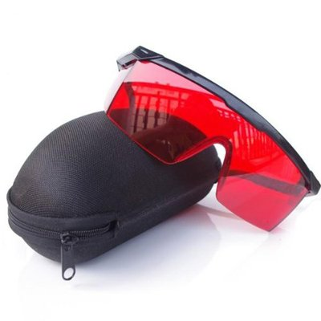

# **QQ-Tech® Goggles Laser Eye Protection Safety Glasses Goggle Glass Shield with Case for Green Blue Laser Pointer**

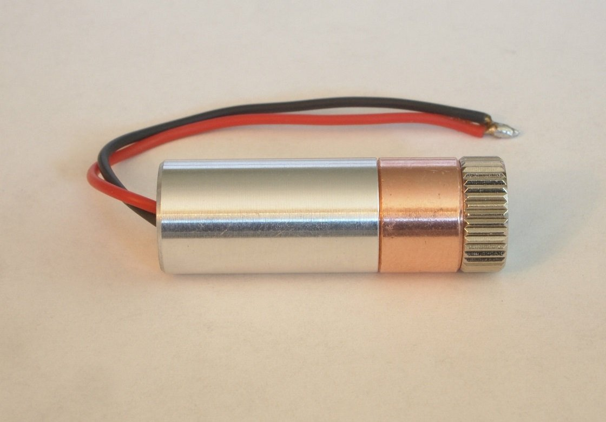

# **2W 445nm M140 Blue Diode in Copper Module W/Leads**

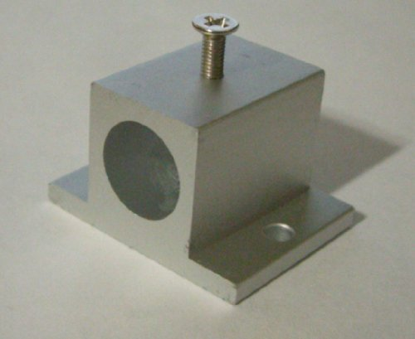

# **AixiZ aluminum mount and heat sink for 12mm modules**

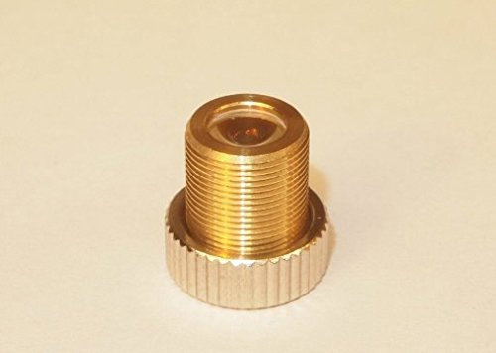

# **405-G-2 Glass Lens for Aixiz Laser Module 405nm 445nm**